# Name: _______________ StudentID: ___________

## Activity 1 - Human Computer Interface (HCI) Analysis

## 

### Crown Casino: [[http://www.crownmelbourne.com.au](http://www.crownmelbourne.com.au/)]:

Here is a snapshot of Crown Casino's home page:

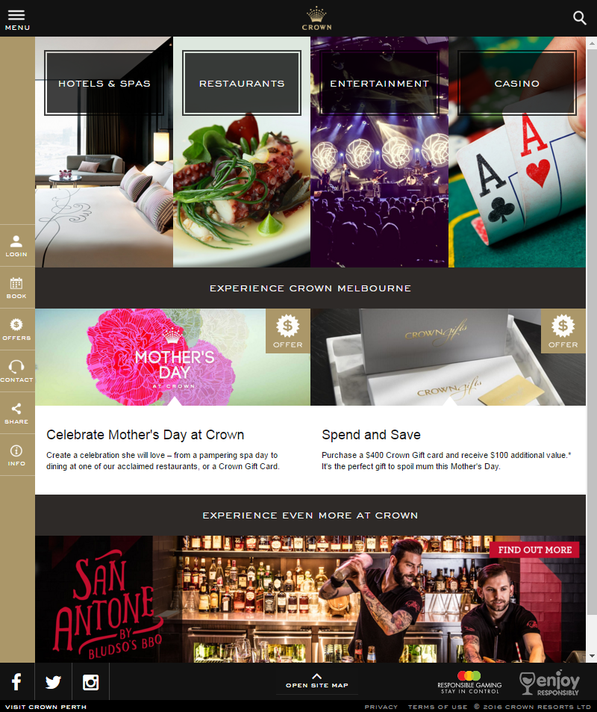

Discuss the following questions:

What are the four business areas they are promoting on the home page? What types of audiences are they appealing to?  
Hotels & bar (those who wants to stay overnight/ have drinks)

Restaurants (those who stay at the hotels and want to grab some food or anyone who just want to have a meal)

Entertainment (those who just want a blast with friends)

Casino (main type of customers who come just to play casino)

* Is the content on this home page (landing page) general in nature? Does it capture all audiences without alienating anyone?  
  The content captures its target audiences who are adults that interested in casino and offer side services for their stay. It also alienates younger audiences with the dark color tone in the homepage as it is not a service for them.
* Are there any issues with contrast that will impact the visually impaired? Have any compromises been made in the name of stylish design? Test your color choices here: <https://contrast-ratio.com/>

The contrast in navigation bar as the white might be hard to see with a slightly dark yellow background.

Uniform font for each section. Sections separated by a black bar with white text, contents are in the area with white background.

* Is the interface at all confusing? Does this website pose any problems for those with mobility or intellectual disabilities?

Overall, the interface is well documented, and users can get used to it quickly

Crown Casino charges rent from their commercial tenants. The success of Crown's business depends on the success of the tenants' businesses and so it makes sense for Crown to promote their tenants' businesses within their website. Below is a screenshot from the restaurant's and food market businesses category:

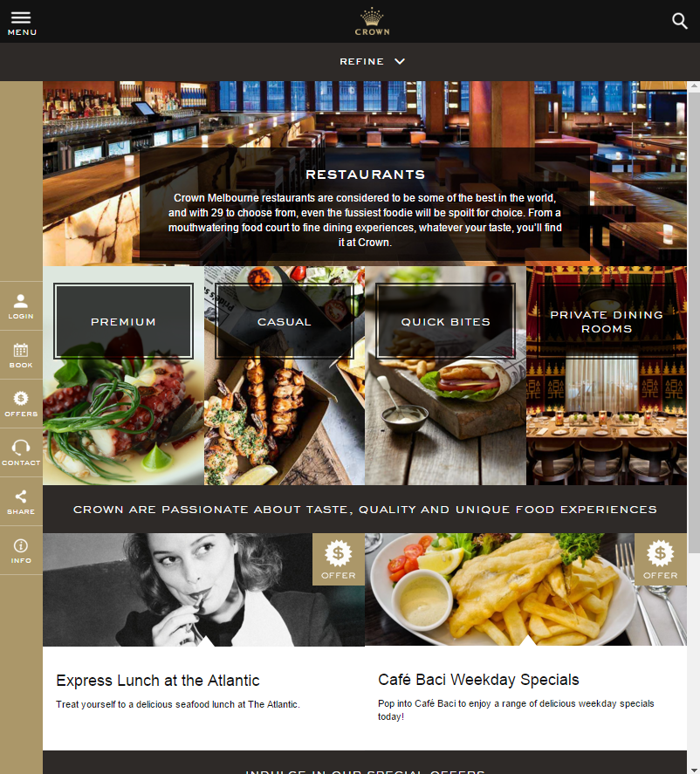

The content on this landing page is more specific: relating to places to eat, but it is still a landing page for 4 general types of audience. Name the 4 types of audience and is there any significance with the placement of each group of restaurants on the page?

Premium for the rich who wants luxurious meal

Casual for those who want a casual meal with family

Quick bites for those who want light food at a rather price

Private dining room for those who want to hold a luxurious party

For the first 3, it is listed from high to low price and low scale meal which target most people that visit the casino. The last one is at a larger scale for a group of people which rarely happen.

Think about what might attract each group and what would "scare" them away? In particular, how does it appeal to those looking for a lavish place to eat (eg Heston Blumenthal's restaurant?) without intimidating those who are on a budget and just want to visit KFC or McDonalds?